**Stamford University Bangladesh**



Online Chocolate shop Management System

Presented By : Crazy Engineers

Department of Computer Science & Engineering

Data Flow Diagram

Submitted By:

* Md Nazim Uddin CSE 063 07429
* Priyanka Rani Satu CSE 063 07380
* Md. Naeemul Hasan CSE 063 07438
* Janith Sultana Juthi CSE 063 07477

# **Introduction:**

Our today’s report has covered into the most important part of this project that is the Data Flow Diagram. Data Flow Diagram is a way of representing a flow of data of a process or a system. It also provides information about the outputs and inputs of each entity and the process itself.

**Data Flow Diagram (DFD):**

**Activity List:**

|  |  |  |
| --- | --- | --- |
| **Purchase** | **Administration** | P**ayroll** |
| Visit | Content Add/Delete/Update | Employee Information |
| BillPay | Customer feedback monitoring | Salary Calculation |
| Online Purchase | Employee report monitoring | Work pace of Employee |
| Service Feedback | Product store monitoring |

**Main Process**: Online Chocolate Shop Management System

**Sub Process**: Purchase, Administration, Payroll

**Entity**: Customer, Employee, Manager, Admin,

**Database**: Order_Info, Product-Store_Info, Customer_Info, Content_Info, Employee_Info, Deliver_Info, WorkTime, Employee_Salary, Report, Feedbac

**DFD - Context Level:**

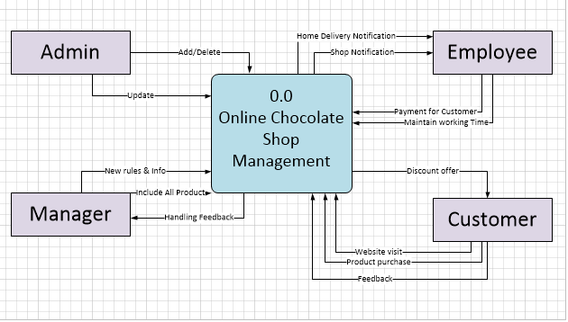

**DFD – Level 0:**

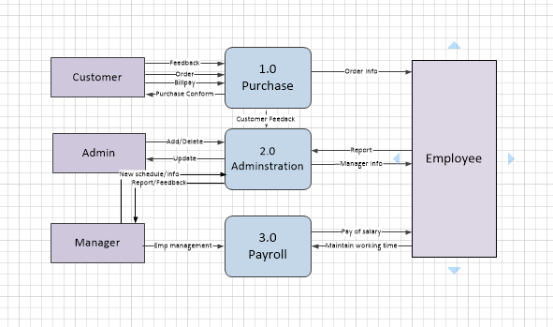

**DFD - Level 01:**

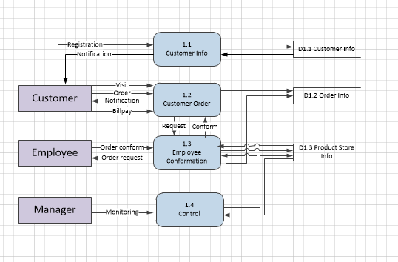

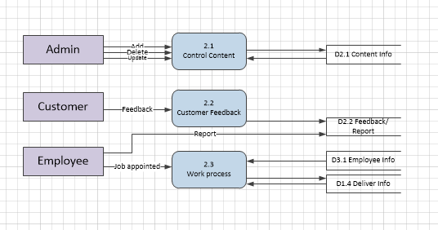

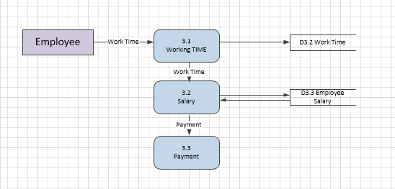

**Process Decomposition:**

|  |  |  |
| --- | --- | --- |
| **Context Level** | **Level -0** | **Level-1** |
| Online Chocolate Shop Management | 1.0 Purchase | 1.1 Customer Information |
|  | 1.2 Customer Order |
| 1.3 Employee Conformation |
| 1.4 Control |
| 2.0 Administration | 2.1 Control Content |
|  | 2.2 Customer Feedback |
| 2.3 Work process |
| 3.0 Payroll | 3.1 Working TIME |
|  | 3.2 Salary |
| 3.3 Payment |

**Conclusion:**

This project concludes the Data Flow Diagram which is being processed data and it helps us to know how the Data Flow Diagram works.